Gridless Wireless Network

Specific Design Detail

**Team name**:

Off the Grid

**Team members:**

Ian Schneier

Linda Palacios

Weikang Zhang

Xucheng You

Jingwen Luo

Alec Motazedi

**Project Sponsor:**

Prof. Alan Mickelson

## ***Circuit and Logic diagrams, labeled parted***

Schematic figure 1:

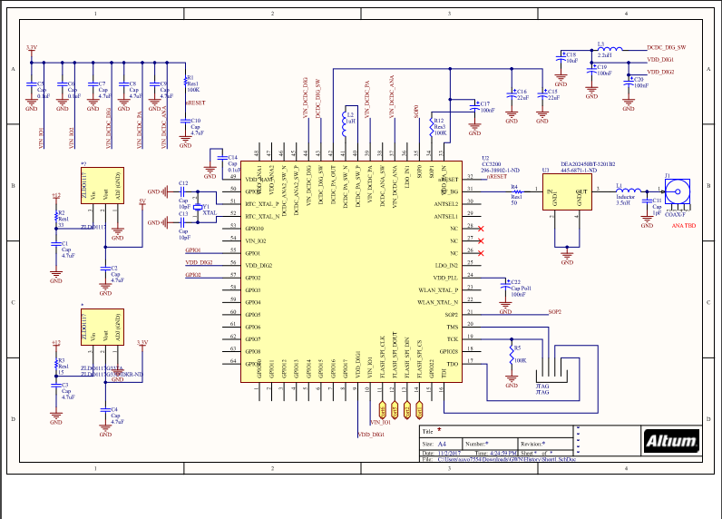

Schematic figure 2:

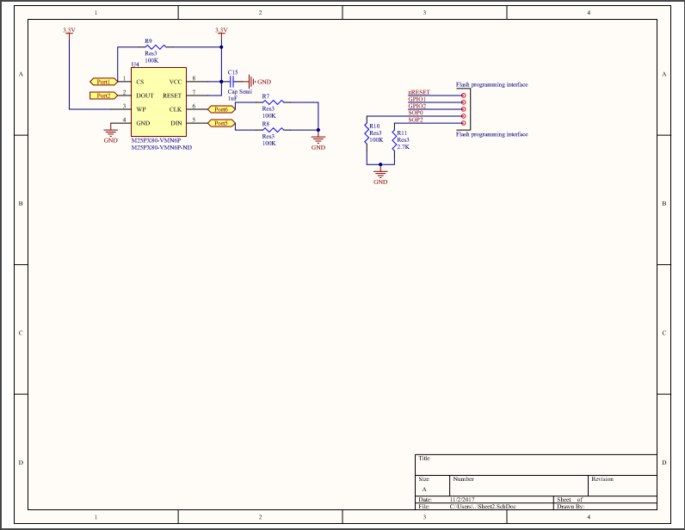

## 

Budget generated from schematic:

## ***BOM.PNG***

## *The budget is list under the excel file call “Budget’

## *Sponder proof of our overall budget have been upload to another file called “Bill of Materials and Sponsor approval for overall budget”

## ***Responsibilities, roles***

|  |  |  |
| --- | --- | --- |
| **Name** | **Operational** | **Technical/Functional** |
| Zhang | Signal Processing | Power and Communications |
| Regina | Codebase Manager | Software/Applications |
| Ian | Co-lead | Hardware/Embedded |
| Alec | Finance Manager and Documents Manager | RF and Software/Applications |
| Xucheng | Co-lead | Power |
| Linda | Communications Manager | Embedded and Software/Application |

## ***Division of labor***

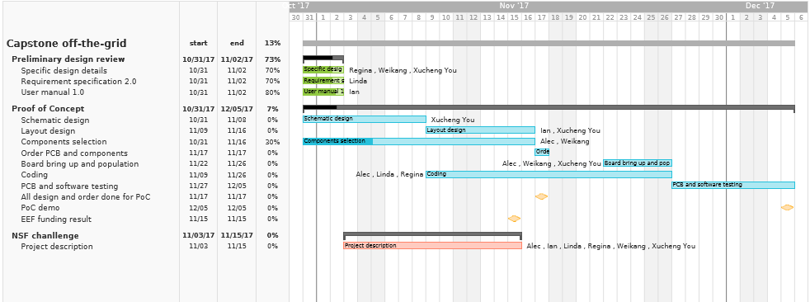

## ***Risk***

The risks that our project has are organized into three categories: hardware, communications, and software.

For hardware, the concerns revolve around the reliability of the components and parts that are used. The biggest risk in this category is that the battery life will be less than the desired 72 hours, which can be mitigated by selecting power efficient circuit elements. Also, because the battery will be rechargeable the charging port may possibly be exposed to water so the charging port must be designed to be waterproof. Consideration is also made regarding the risk of the device falling so the enclosure must be designed to resist the impact force of hitting the ground from a certain height so the device remains intact. Weight distribution is another concern since the device cannot operate properly if it tips over so we have to ensure our final design is bottom heavy to ensure it stays upright when exposed to strong winds and other phenomena that could knock it down.

Concerns regarding the communications focus on the reliability of the system to provide a reliable connection. One of the issues relating to this is the possibility of the device being unable to provide the acceptable data bandwidth to handle the anticipated amount of users connected to the network. Besides user capacity, attention should be given to which antenna will be selected for the final design so that the final design for our product will have the best signal reception possible.

In terms of software related risks the biggest concern is ensuring that the devices can successfully pair with each other. If any issues arise that impede this then our product will be an utter failure. Besides having the devices close to each other to ease pairing, software based solutions will have to be devised to mitigate any difficulty that can occur from the devices performing their primary function of creating the mesh network communication system. We also need to ensure that any data that can be gathered such as location, connected device battery life, and other information concerning the well being of the users will be gathered effectively so that the relief organizations that will use our product will be correctly informed regarding who needs help and where.

## 

## 